For BCTS Client Use
CONTRACTOR | WATCHMAN
Location (Block): | Date:
Worksite Location: | Number of Workers:
Weather Station: | Early Shift: Yes □ No □
Operations – Start Time: | Operations – End Time:
Fire Watch Start Time: | Fire Watch End Time:

For definitions of Early Shift, High Risk Activities and Danger Class Restrictions, See Wildfire Regulation and BCTS Client eERP | Previous Days Danger Class Rating  (I,II,III, IV,V)  Fire Watch Required: Yes No
  Date
  Danger

Today’s Weather (Circle Appropriate Icon)

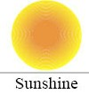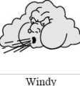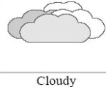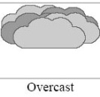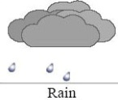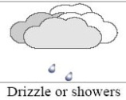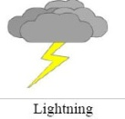

Est. Midday Temperature (°C) Est. Wind Speed (KM/H) (SEE BEAUFORT SCALE BELOW)

Block Walk Thru | Observed / Inspected | Fire Observed |  |  | Description of area walked and times)
Observe all areas of high risk activities. |  | YES | NO | N/A | (i.e. FC 1-10, SW corner of Block
Buncher Work Area
Skidders Work Area
Processor Work Area
Loader Work Area
Site Prep Work Area
Brushing Work Area
Other
Communications Checked

Tank Size, total amount of hose, locations:

Observations:

Fire Watch Signature:

BEAUFORT SCALE
WIND SPEED  (KPH) | NAME | DESCRIPTION
<1 | calm | calm; smokes rises vertically
1-5 | light air | direction of wind shown by smoke but not by wind vanes
6-11 | light breeze | wind felt on face; leaves rustle; wind vane moves
12-19 | gentle breeze | leaves and small twigs in constant motion; wind extends light flag
20-28 | moderate breeze | wind raises dust and loose paper; small branches move
29-38 | fresh breeze | small-leaved trees begin to sway; crested wavelets form on inland waters
39-49 | strong breeze | large branches move; overhead wires whistle; umbrellas difficult to control
50-61 | moderate gale or near gale | whole trees sway; walking against wind is difficult
62-74 | fresh gale or gale | twigs break off trees; moving cars veer
75-88 | strong gale | slight structural damage occurs; shingles may blow away
89-102 | whole gale or storm | trees uprooted; considerable structural damage occurs
103-117 | Storm or violent storm | widespread damage occurs
>117 | hurricane* | widespread damage occurs

